MED D - Specialized Member Services Team (SMST) - Voluntary Disenrollment

Disenrollment Procedures
Checking the Status or Providing More Information for a Disenrollment Request
Related Documents

Description: The document assists the Specialized Member Services Team (SMST) with providing the beneficiary the options for voluntary disenrollment when the beneficiary is currently active in the Medicare Prescription Drug Plan.

This document should only be used by the Specialized Member Services Team (SMST).

Note:
- Health Plans/EGWP - Refer to the CIF to determine if the plan handles the situations outlined in this document.
  - If Client handles, follow direction provided in CIF.
  - If SMST handles, transfer to SMST. Refer to MED D - Guide to Transferring a Call.
- SilverScript (x9110) - Warm transfer to the SMST. Refer to MED D - Guide to Transferring a Call.
- For all other clients - Refer to Transferring Calls to Dedicated Teams Process.

Disenrollment Procedures
The CCR is required to complete all talk tracks and steps in this document.

Perform the steps below:
Step | Action
1 | Verify if the beneficiary is currently active in PeopleSafe.
1 | If… |  |  | Then…
1 | Beneficiary is active |  |  | Proceed to the next step.
1 | Future active |  |  | Proceed to MED D - Cancellation of Enrollment.
1 | Already disenrolled |  |  | If the beneficiary wishes to discuss the disenrollment issue:  - Refer to MED D - Specialized Member Services Team (SMST) - PeopleSafe Disenrollment Reason - Processes and References  If the beneficiary states that there has been an error in their disenrollment or does not agree with their disenrollment date  - Refer to MED D - Specialized Member Services Team (SMST) - Mistaken Disenrollment of a Beneficiary.
1 | Beneficiary needs to provide further information for a pending request |  |  | Proceed to Checking the Status or Providing More Information for a Disenrollment Request
2 | - Medicare allows you to make changes to your Part D coverage during the Annual Enrollment Period (AEP), which occurs from October 15 through December 7th of each year. To make changes outside of this time you must qualify for a Special Election Period (SEP).  - Do you know if you have a valid Election Period to disenroll?
2 | If… |  | Then…
2 | During AEP |  | Confirm if the beneficiary has a valid SEP or if they wish to disenroll using the AEP (effective January 1).  Note: Refer to MED D - Election Periods for Enrollment and Disenrollment (AEP, IEP, SEP) for Special Election Periods.  Proceed to the next step.
2 | SEP |  | Proceed to the next step.
2 | No  OR  Do not know |  | - If you are unsure if you qualify for a Special Election Period, you may still submit a disenrollment request. However, please note if you do not have a valid election period, Medicare will not accept the disenrollment.  - The following are a list of common Special Election Periods you may qualify for.  Provide the following SEP examples:  - You have both Medicare and Medicaid, or your state helps you pay for your Medicare premiums.  - You have or will gain TriCare, Indian Health Service, or VA coverage.  - You get Extra Help paying for Medicare prescription drug coverage or no longer qualify for Extra Help.  - You are moving into, live in, or recently moved out of a Long-Term Care Facility (for example, a nursing home or long-term care facility).  - You are joining a PACE program  - You are joining or have employer or union coverage.  - You have or will gain other creditable coverage.  Note: If the beneficiary states that they have recently moved to a different state or region and needs to change plans or wants to disenroll, refer to MED D – Address Changes and Out of Area (OOA).  Refer to the MED D - Election Periods for Enrollment and Disenrollment (AEP, IEP, SEP) job aid for additional Special Election Periods.  Proceed to the next step.
3 | You may choose one of the following options to disenroll from a Medicare Part D plan:  - First, you can enroll in another Part D Plan or Medicare Advantage plan with prescription drug coverage. This should automatically disenroll you from your current plan.  - Second, you may submit a request in writing via Fax or Mail. To expedite this process, you may download a disenrollment form via Aetnamedicare.com or we can send you one by mail. Please note Medicare requires SilverScript to obtain all disenrollment requests in writing and cannot process a disenrollment by phone.  - Finally, you may call 1-800-633-4227 (1-800 MEDICARE) and ask for a Medicare Disenrollment Specialist to assist you in disenrolling from the plan. Please note that your request may not be completed if you do not speak to a Disenrollment Specialist.  Proceed to the next step.
4 | Refer to the appropriate option that the beneficiary chooses, or provide all information:
4 | Option… | Then…
4 | 1 – Enroll into another plan | Please be aware that if the prescription drug coverage plan is not by a Medicare Part D (PDP) or Medicare Advantage (MAPD) plan, you may still need to submit a disenrollment request.  Examples of non-Part D plans that require voluntary disenrollment: Employer/Union, including the Federal Employees, Medicaid, State Pharmaceutical Assistance Program, VA benefits, TRICARE or other military coverage, Indian Health Service  Proceed to the next step.
4 | 2a – Written Request | The following information must be included in your written request:  - Subscriber/Member ID or MBI  - Beneficiary’s Name and Date of Birth  - A brief statement providing the reason for disenrollment and any Special Election Period you might qualify for.  Please ensure your written request is signed and dated.  - For expedited processing, we strongly recommend faxing your request to 866-552-6205  - Or you can mail your request to:  SilverScript  PO Box 30007  Pittsburgh, PA 15222-0330  - Please be aware that requests to disenroll using a Special Election Period (SEP) are processed during the month submitted and if approved, will be effective the first day of the following month. Any request to disenroll using an SEP will be processed based on the date received by the plan and cannot be processed retroactively or for a future date.  Proceed to the next step.
4 | 2b – Written Request - Disenrollment Form | I will gladly mail you a disenrollment form to assist you in completing the written request. Please note that standard mail delivery times apply and may be longer during certain times of the year.  Note: If the beneficiary requests the disenrollment form to be mailed and there is less than 15 days left in the month or 15 days prior to December 7th, strongly urge the beneficiary to pursue other options to ensure their request is received timely.  For expedited processing, we strongly recommend obtaining the form on our website by visiting Aetnamedicare.com. May I assist you in obtaining that form online?
4 | 2b – Written Request - Disenrollment Form | If… |  |  | Then…
4 | 2b – Written Request - Disenrollment Form | Yes, beneficiary will obtain form online |  |  | Navigate to aetnamedicare.com using a web browser.  - Click on For Members  - Click Get a Form in the Member Resources list  - Click Leave or cancel my prescription drug plan (PDP)  - Click Learn how to disenroll from your PDP  - Under the How do I disenroll from my prescription drug plan (PDP) section, Select the appropriate disenrollment form.  - Please be sure to complete all necessary information on the form and Sign and Date the request. For expedited processing, we strongly recommend faxing your request to 866-552-6205. Or you may mail your request to:  SilverScript  PO Box 30007  Pittsburgh, PA 15222-0330  - Please be aware that requests to disenroll using a Special Election Period (SEP) are processed during the month submitted and if approved, will be effective the first day of the following month. Any request to disenroll using an SEP will be processed based on the date received by the plan and cannot be processed retroactively or for a future date.  - If Medicare approves your request, they will ask us to process your disenrollment and you will receive a notice through the mail that you have been disenrolled.  - As a courtesy we will also be mailing you a disenrollment form.  Proceed to the next step
4 | 2b – Written Request - Disenrollment Form | No (beneficiary requests mailed form) |  |  | When you receive the form, please be sure to complete all necessary information on the form and Sign and Date the request.  - For expedited processing, we strongly recommend faxing the request to 866-552-6205 Or, you may mail your request to:  SilverScript  PO Box 30007  Pittsburgh, PA 15222-0330  - Please be aware that requests to disenroll using a Special Election Period (SEP) are processed during the month submitted and if approved, will be effective the first day of the following month. Any request to disenroll using an SEP will be processed based on the date received by the plan and cannot be processed retroactively or for a future date.  - If Medicare approves your request, they will ask us to process your disenrollment and you will receive a notice through the mail that you have been disenrolled.  - As a courtesy we will also be mailing you a disenrollment form.  Proceed to the next step.
4 | 3 – Contact Medicare Disenrollment Specialist | - You may contact 1-800-633-4227 (1-800-MEDICARE) and ask to speak with a disenrollment specialist to request disenrollment from your Medicare Part D plan. Please be aware that the hold times to speak to a representative may be longer during certain times of the year such as the Annual Enrollment Period.  - You also will be required to provide information regarding a potential Special Election Period (SEP).  - Please be aware that requests to disenroll using a Special Election Period (SEP) are processed during the month submitted and if approved, will be effective the first day of the following month. Any request to disenroll using an SEP will be processed based on the date received by the plan and cannot be processed retroactively or for a future date.  - If Medicare approves your request, they will ask us to process your disenrollment and you will receive a notice through the mail that you have been disenrolled.  - As a courtesy we will also be mailing you a disenrollment form.  Proceed to the next step.
5 | - Please keep in mind that if you disenroll and do not obtain other coverage that is at least as good as Medicare Part D drug coverage (also referred to as creditable coverage), you may be subject to pay a penalty if you enroll in Medicare Part D prescription drug plan in the future.  - You are responsible for the payment of any premiums that may be billed prior to your disenrollment effective date.  Proceed to the next step.
6 | Send a Disenrollment form to the beneficiary as a courtesy.  In PeopleSafe:  - Click on Medicare D Inquiry Tab.  - Click on the Fulfillment Request Tab.  - From the Fulfillment List, select the Disenrollment Form and click Add.  - Click Save Order.  Proceed to the next step.
7 | Document the call with the following information:  - You have provided all disenrollment request options  - The qualifying Election Period if provided  - How the beneficiary will submit the disenrollment request  Log Activity:  1306 - Enrollment/Disenrollment
8 | Close the call. Refer to MED D - Call Documentation.  SMST refer to the Close Your Beneficiary Experience in the  MED D - Specialized Member Service Team (SMST) - Call Flow and Commonly Used Work Instruction Index.

Top of the Document

Checking the Status or Providing More Information for a Disenrollment Request

If a beneficiary calls to check on the status of his/her disenrollment request or to provide more information to complete a disenrollment request, the CCR will:
Step | Action
1 | Check Medicare D Inquiry – Participant Details and review the following fields:  - Disenrollment Application Date  - Disenrollment Reason  - Medicare Interface Transaction  - Medicare Interface Effective  - Medicare Interface Status  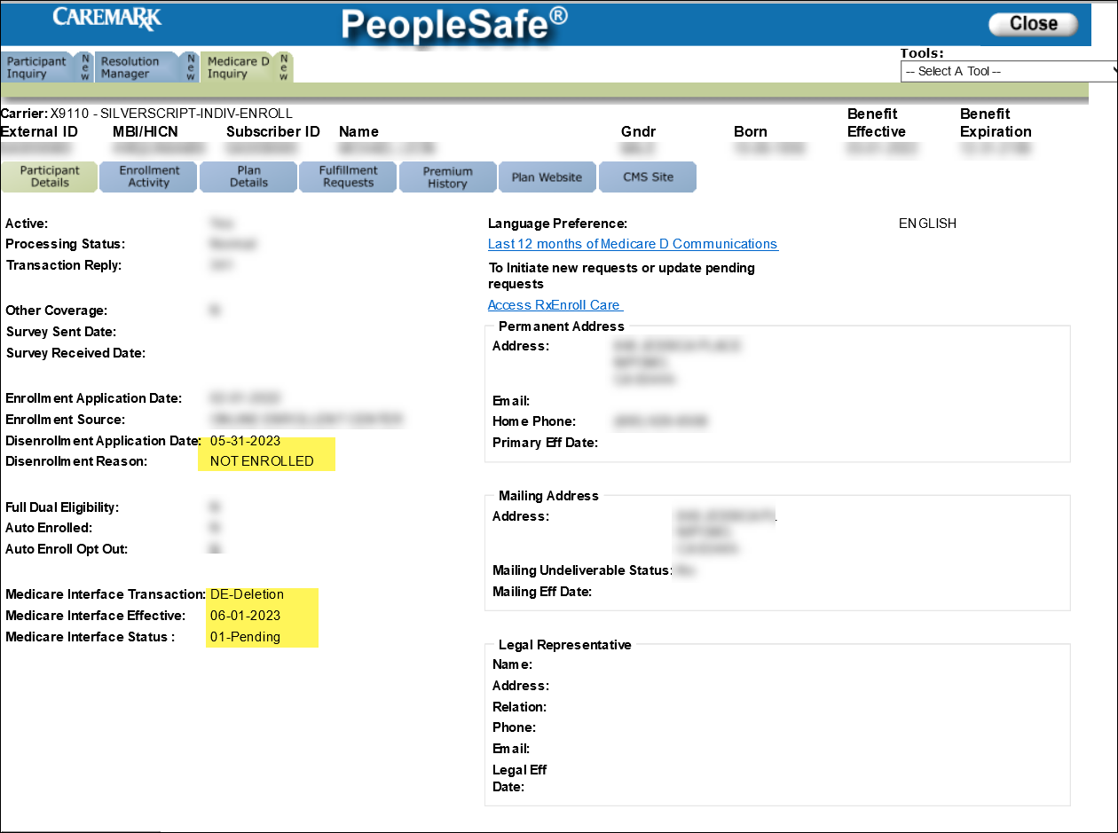
1 | If the disenrollment request is… | Then…
1 | Approved | - Your disenrollment request was sent to Medicare.  - You should receive a confirmation of our receipt of the disenrollment request within 15 days.  - You will also receive an additional confirmation that Medicare has accepted the request.  - Please keep in mind that you are still responsible for any premiums that may have been billed to you prior to your disenrollment effective date.  Proceed to the next step.
1 | In Progress/Missing information | Check View Comments in the Participant Inquiry tab to verify the status of the beneficiary’s disenrollment request and whether any additional information was needed for processing.  Example:  Missing elements:  - Intent – beneficiary wants to disenroll – direct statement  - SEP – Valid Election Period – 5 days to respond  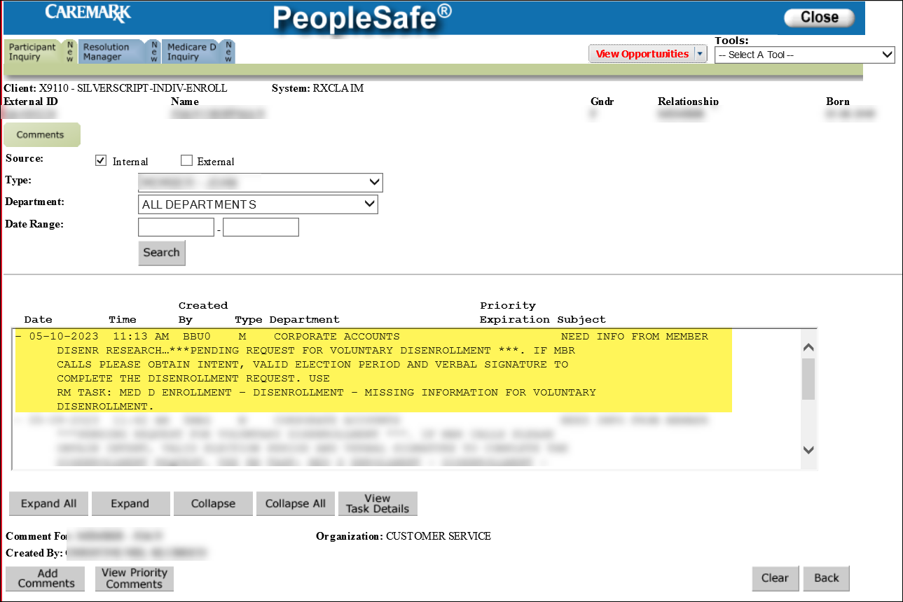  Note: Customer Care tells the beneficiary we are submitting the information however, if past the deadline to provide information, a new disenrollment request may need to be submitted.  We need more information before a decision can be made regarding your disenrollment request.  CCR Process Note: Ask the beneficiary/authorized caller to provide the following information that is required for the request and submit the following RM Task:  Task Category: Med D Enrollment - Disenrollment  Task Type: Missing Information for Voluntary Disenrollment  Queue: Med D Enrollment Task  Notes:  - Qualifying Election Period for the disenrollment.  - Signature  - Beneficiary/ Legal Representative can verbally attest to the disenrollment  - If Legal Representative is providing verbal attestation obtain the following information and document in call notes:  - Representative First and Last Name  - Phone #  - Address  - Relationship  You should receive a decision regarding your request within 15 calendar days of our receipt of the disenrollment request.  Reminder: Only CMS can approve or deny a beneficiary’s request for disenrollment.  Proceed to next step.
2 | Ask if there are any other benefit questions.
2 | If… | Then…
2 | Yes | - Address any benefit issues.  - Document and close the call according to current policies and procedures.  - Refer to MED D - Call Documentation.  Log Activity:  1306 - Enrollment/Disenrollment
2 | No | Close the call. Refer to MED D - Call Documentation.  SMST refer to the Close Your Beneficiary Experience in the  MED D - Specialized Member Service Team (SMST) - Call Flow and Commonly Used Work Instruction Index.

Top of the Document

Related Documents
- Grievance Standard Verbiage (for use in Discussion with Beneficiary) section in MED D - Grievances Index
- MED D Enrollment - FAZAL
- MED D - SHIP Counselor Calls for CVS Caremark Part D Plans
- MED D - Appointed Representative Form (AOR) or Power of Attorney (POA)
- MED D - SilverScript and Blue MedicareRx (NEJE) - Enrollment Related RM Tasks
- MED D - Election Periods for Enrollment and Disenrollment (AEP, IEP, SEP)
- MED D - CMS Passive Enrollment in MMP - Required Voluntary Disenrollment from the PDP, Opt-Out and Disenrollment from the MMP

Parent SOP: CALL-0048: Medicare Part D Customer Care Call Center Requirements-CVS Caremark Part D Services, L.L.C.
Abbreviations/Definitions: Abbreviations / Definitions

Top of the Document

Not to Be Reproduced or Disclosed to Others without Prior Written Approval
ELECTRONIC DATA = OFFICIAL VERSION / PAPER COPY = INFORMATIONAL ONLY

